Internal Order for Conveyance Reimbursement – User Manual ( Client 100)

- Create Internal Order in Transaction Code KO01

Maintain the settlement rule in the order ie Cost Center to which the order is to be settled:
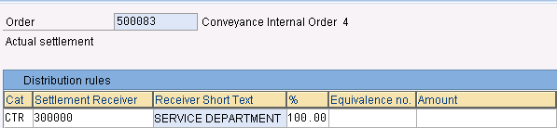

- Create Internal Order Group for Conveyance Internal Orders – T Code KOH2

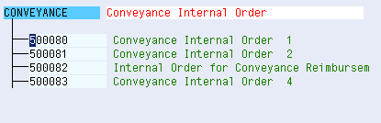

- Define Budget for Internal Orders – KO22

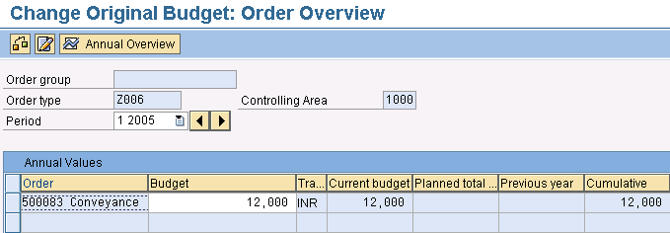

- View report S_ALR_87013019 - List: Budget/Actual/Commitments

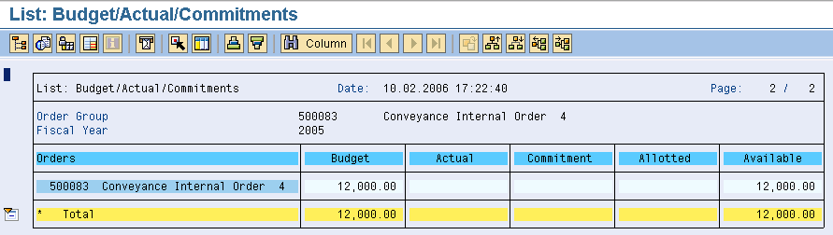]

- Refer the Internal Order no. while booking the conveyance expenses FBCJ.

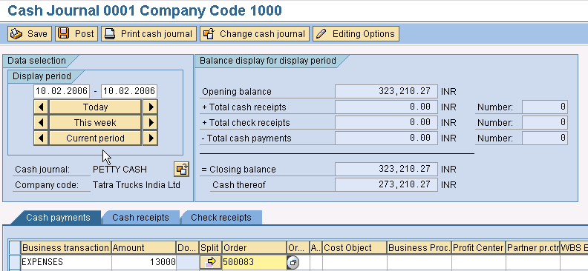

If the Actual expenses exceeds the budget amount system will throw an error message.

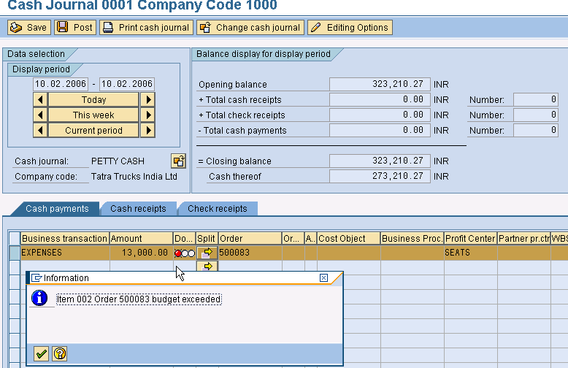

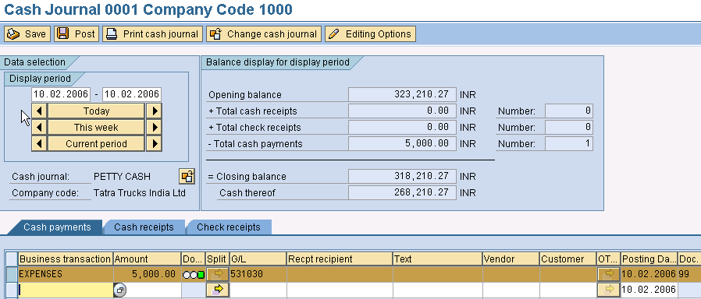

- View the report S_ALR_87013019 - List: Budget/Actual/Commitments

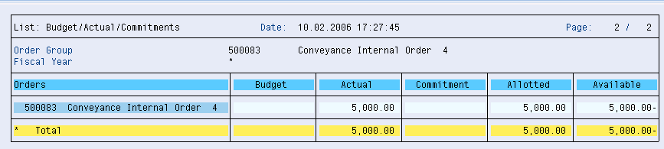

- Use transaction code KO8G to settle the Order Group

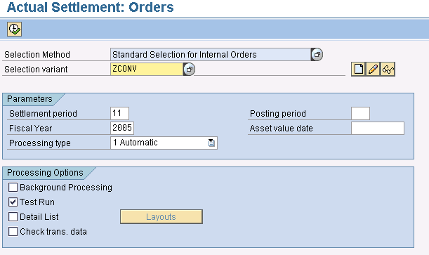

This Settlement activity is a periodical activity and it has to be run monthly and then only controlling will show the correct picture.

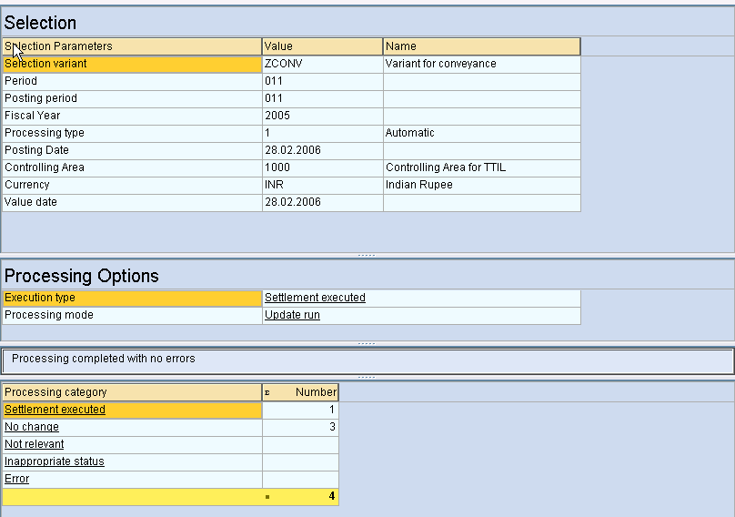

- View the report S_ALR_87013015 - List: Actual Debit/Credit to see the actual Credit and Debit booked to the Internal Orders.

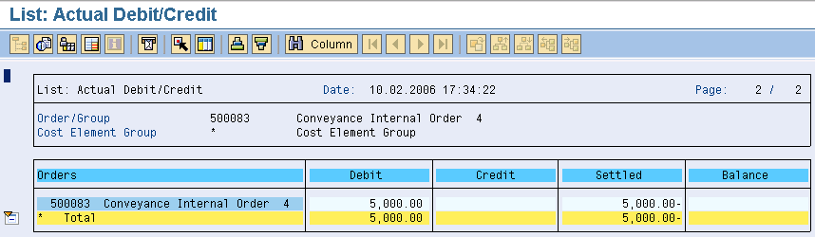

- To view the settlement rules for Internal Orders: KOSRLIST_OR - Settlement Rules

